Oblique (Diagonal) Ray
# Source: AI Source: Provided by: [Data Path: Persons Table -> ID Column: 1, Name_En Column: Motasem Essam] -> From: [ChatGPT] on [7/25/2026]
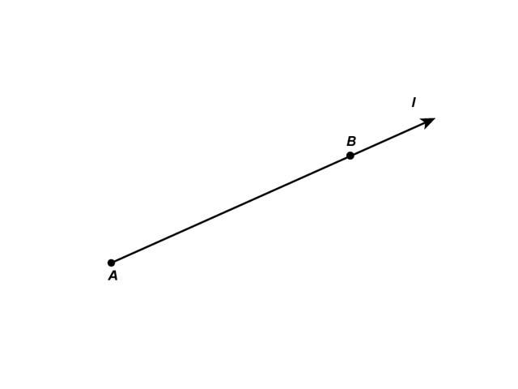
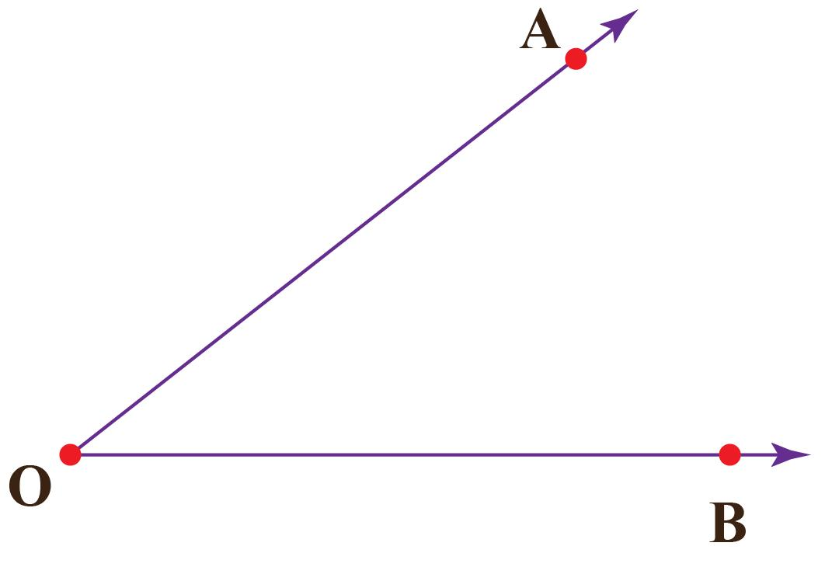
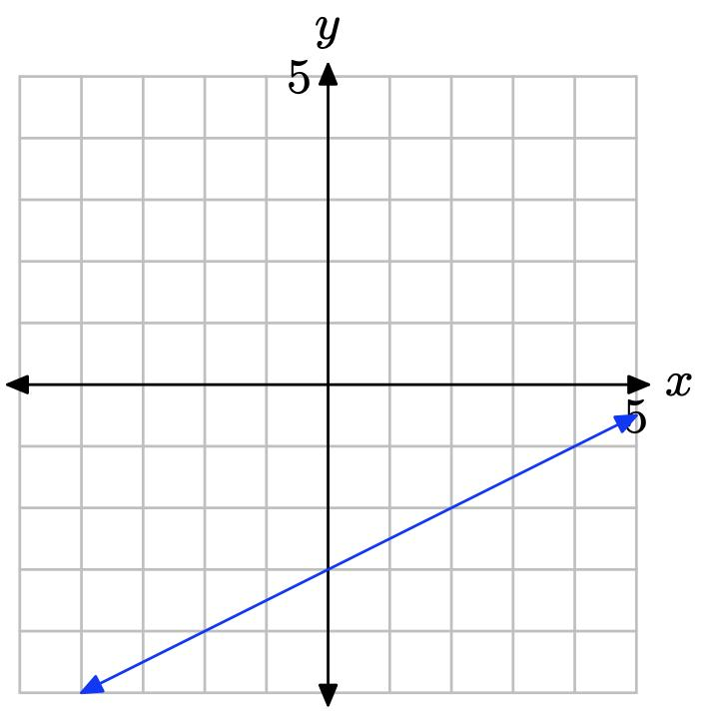
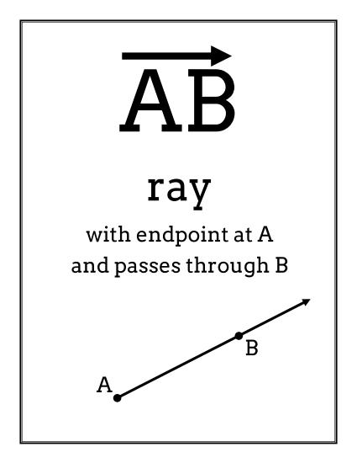

Definition
# Source: AI Source: Provided by: [Data Path: Persons Table -> ID Column: 1, Name_En Column: Motasem Essam] -> From: [ChatGPT] on [7/25/2026]
An Oblique Ray (also called a Diagonal Ray or Slanted Ray) is a ray that extends infinitely in one inclined direction from a fixed endpoint. It is neither horizontal nor vertical, forming an angle with both the horizontal and vertical axes.
Unlike an oblique line or oblique line segment, an oblique ray has one endpoint and extends infinitely in only one direction.

Characteristics
# Source: AI Source: Provided by: [Data Path: Persons Table -> ID Column: 1, Name_En Column: Motasem Essam] -> From: [ChatGPT] on [7/25/2026]
An oblique ray:
- Has one endpoint.
- Extends infinitely in one direction.
- Is neither horizontal nor vertical.
- Has a defined, non-zero slope.
- May slope upward or downward.
- Represents a directed inclined path.

Illustration
# Source: AI Source: Provided by: [Data Path: Persons Table -> ID Column: 1, Name_En Column: Motasem Essam] -> From: [ChatGPT] on [7/25/2026]
Positive Slope Ray
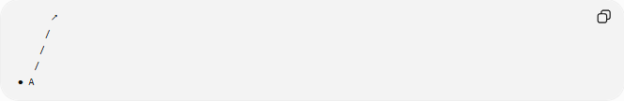
↗
/
/
/
● A
The ray rises from left to right.

Negative Slope Ray
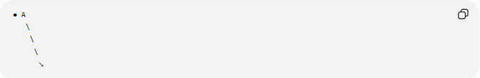
● A
\
\
\
↘
The ray falls from left to right.

Coordinate Geometry
# Source: AI Source: Provided by: [Data Path: Persons Table -> ID Column: 1, Name_En Column: Motasem Essam] -> From: [ChatGPT] on [7/25/2026]
An oblique ray begins at:
$$A\left(x_{0} , y_{0}\right)$$
and extends infinitely in one inclined direction.

Example
Starting point:
$$A\left(2 , 3\right)$$
Passing through:
$$B\left(5 , 6\right)$$
Direction vector:
$$\left(3 , 3\right)$$
The ray starts at $A$and extends infinitely beyond $B$.

Slope
The slope is
$$m=\frac{Δy}{Δx}$$
where
$$m≠0$$

Positive Slope
If
$$m>0$$
the ray rises from left to right.
Example:
$$m=2$$

Negative Slope
If
$$m<0$$
the ray falls from left to right.
Example:
$$m=-\frac{1}{2}$$

Examples
# Source: AI Source: Provided by: [Data Path: Persons Table -> ID Column: 1, Name_En Column: Motasem Essam] -> From: [ChatGPT] on [7/25/2026]
Examples of oblique rays include:
- A flashlight beam pointed diagonally.
- A laser beam projected at an angle.
- A sloped arrow in a diagram.
- A radar beam scanning upward.
- A ramp extending from a fixed point.

Properties
# Source: AI Source: Provided by: [Data Path: Persons Table -> ID Column: 1, Name_En Column: Motasem Essam] -> From: [ChatGPT] on [7/25/2026]
An oblique ray:
- Has one endpoint.
- Extends infinitely in one inclined direction.
- Has a defined, non-zero slope.
- May have either a positive or negative slope.
- Is not parallel to either the x-axis or y-axis.

Applications
# Source: AI Source: Provided by: [Data Path: Persons Table -> ID Column: 1, Name_En Column: Motasem Essam] -> From: [ChatGPT] on [7/25/2026]
Oblique rays are used in:
- Plane Geometry
- Coordinate Geometry
- Engineering
- Architecture
- Construction
- Surveying
- CAD (Computer-Aided Design)
- Technical Drawing
- Computer Graphics
- Robotics

Advantages
# Source: AI Source: Provided by: [Data Path: Persons Table -> ID Column: 1, Name_En Column: Motasem Essam] -> From: [ChatGPT] on [7/25/2026]
Studying oblique rays helps to:
- Understand directed geometric objects.
- Model directional movement.
- Analyze slope and inclination.
- Construct geometric figures.
- Represent light rays and trajectories.

Limitations
# Source: AI Source: Provided by: [Data Path: Persons Table -> ID Column: 1, Name_En Column: Motasem Essam] -> From: [ChatGPT] on [7/25/2026]
An oblique ray:
- Extends in only one direction.
- Represents only one inclined orientation.
- Has only one endpoint.

Comparison with Related Objects
# Source: AI Source: Provided by: [Data Path: Persons Table -> ID Column: 1, Name_En Column: Motasem Essam] -> From: [ChatGPT] on [7/25/2026]
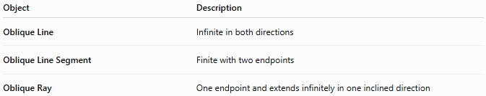
Object | Description
Oblique Line | Infinite in both directions
Oblique Line Segment | Finite with two endpoints
Oblique Ray | One endpoint and extends infinitely in one inclined direction

Key Points
# Source: AI Source: Provided by: [Data Path: Persons Table -> ID Column: 1, Name_En Column: Motasem Essam] -> From: [ChatGPT] on [7/25/2026]
- An Oblique (Diagonal) Ray has one endpoint.
- It extends infinitely in one inclined direction.
- It has a defined, non-zero slope:
$$m≠0$$
- It may have a positive or negative slope.
- It is neither horizontal nor vertical.
- Oblique rays are widely used in geometry, engineering, architecture, surveying, CAD, technical drawing, robotics, and computer graphics.

Conclusion
# Source: AI Source: Provided by: [Data Path: Persons Table -> ID Column: 1, Name_En Column: Motasem Essam] -> From: [ChatGPT] on [7/25/2026]
An Oblique (Diagonal) Ray is a geometric figure that begins at a fixed endpoint and extends infinitely in one inclined direction. Unlike horizontal or vertical rays, it forms an angle with both coordinate axes and has a defined positive or negative slope. Oblique rays are fundamental in plane geometry, coordinate geometry, engineering, architecture, construction, surveying, CAD, technical drawing, robotics, and computer graphics, where they are used to represent directed paths, light beams, trajectories, and inclined geometric relationships.

